Cursus Back-End Developer

Les 7 – Formulieren

**Voorbeeld <form> en <input> (zie bijlage)**

<!DOCTYPE html>

<html>

<head>

<meta charset="utf-8"><title>Formulier</title>

</head>

<body>

<input type="text" name="adres" placeholder="Straatnaam en huisnummer">

</body>

</html>

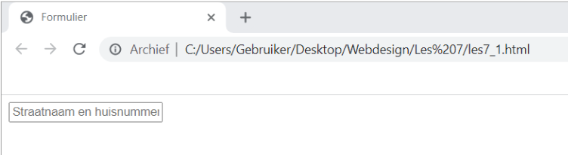

**Verzend button (type, name, value)**

<!DOCTYPE html>

<html>

<head><title>Formulier</title>

</head>

<body><input type="text" name="adres" placeholder="Straatnaam en huisnummer">

<input type="submit" value="Verzend">

</body>

</html>

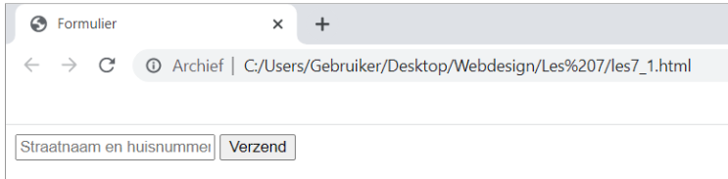

**Button met knopelement (type, name, value)**

<form method="post" action="bewaarInformatie.php">

<input type="text" name="adres" placeholder="Straatnaam en huisnummer">

<button type="submit" name="Verzendknop">

<strong>Verzend</strong></button>

</form>

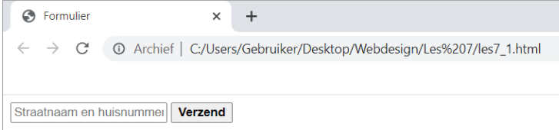

**Wachtwoord (type, name)**

<!DOCTYPE html>

<html>

<head><title>Formulier</title>

</head>

<body><form method="post" action="bewaarInformatie.php">

<input type="text" name="adres" placeholder="Straatnaam en huisnummer">

<input type="password" name="wachtwoord">

<button type="submit" name="Verzendknop">

<strong>Verzend</strong></button>

</form>

</body>

</html>

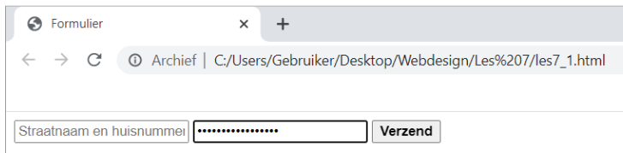

**Cijfers (type, name, value, min, max, step)**

<!DOCTYPE html>

<html>

<head><title>Formulier</title>

</head>

<body><form method="post" action="bewaarInformatie.php">

<input type="text" name="adres" placeholder="Straatnaam en huisnummer">

<p>Uw leeftijd</p>

<input type="number" name="leeftijd" min="1" max="100">

<input type="password" name="wachtwoord">

<button type="submit" name="Verzendknop">

<strong>Verzend</strong></button>

</form>

</body>

</html>

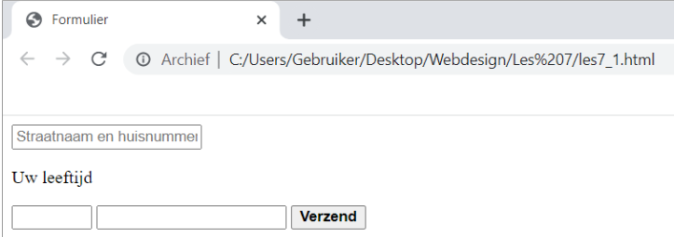

**E-mail, telefoonnummer, URL ( Type, name, value, maxlength, placeholder) In table**

<!DOCTYPE html>

<html>

<head>

<title>Formulier</title>

</head>

<body>

<form method="post" action="bewaarInformatie.php">

<table width="600" border="0">

<tbody>

<tr>

<td width="200"><b>Uw adres</b></td>

<td width="400"><input type="text" name="adres" placeholder="Straatnaam en huisnummer"></td>

</tr>

<tr>

<td><b>Uw leeftijd</b></td>

<td><input type="number" name="leeftijd" min="1" max="100"></td>

</tr>

<tr>

<td><b>Uw wachtwoord</b></td>

<td><input type="password" name="wachtwoord"></td>

</tr>

<tr>

<td><b>Uw e-mailadres</b></td>

<td><input type="email" name="emailadres"></td>

</tr>

<tr>

<td><b>Uw webpagina</b></td>

<td><input type="url" name="webadres"></td>

</tr>

<tr>

<td><b>Uw telefoonnummer</b></td>

<td><input type="tel" name="telefoonnummer"></td>

</tr>

<tr>

<td>&nbsp;</td>

<td><button type="submit" name="verzendknop">

<strong>Verzend</strong></button></td>

</tr>

</tbody>

</table>

</form>

</body>

</html>

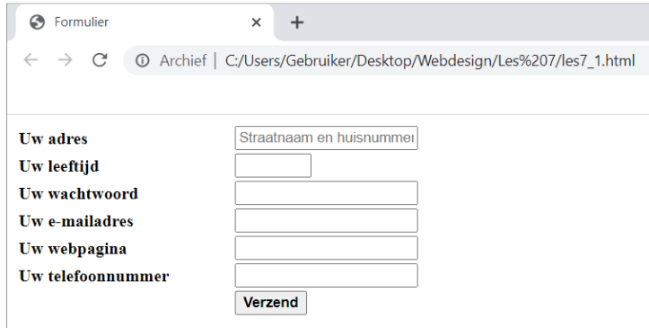

**Datums (type, name, value, min, max, step)**

<!DOCTYPE html>

<html>

<head><title>Formulier</title>

</head>

<body>

<form method="post" action="bewaarInformatie.php">

<table width="600" border="0">

<tbody>

<tr>

<td width="200"><b>Uw adres</b>

</td>

<td width="400">

<input type="text" name="adres" placeholder="Straatnaam en huisnummer">

</td>

</tr>

<tr>

<td><b>Uw leeftijd</b>

</td>

<td><input type="number" name="leeftijd" min="1" max="100">

</td>

</tr>

<tr>

<td><b>Uw wachtwoord</b>

</td>

<td><input type="password" name="wachtwoord">

</td>

</tr>

<tr>

<td><b>Uw e-mailadres</b>

</td>

<td><input type="email" name="emailadres">

</td>

</tr>

<tr>

<td><b>Uw webpagina</b>

</td>

<td><input type="url" name="webadres">

</td>

</tr>

<tr>

<td><b>Uw telefoonnummer</b>

</td>

<td><input type="tel" name="telefoonnummer">

</td>

</tr>

<tr>

<td><b>Uw geboortedatum</b>

</td>

<td><input type="date" name="datum" max="2080-12-31">

</td>

</tr>

<tr>

<td>&nbsp;</td>

<td>

<button type="submit" name="verzendknop">

<strong>Verzend</strong>

</button>

</td>

</tr>

</tbody>

</table>

</form>

</body>

</html>